

PROJECT TITLE | TECH WORKFORCE SALARY & FINANCIAL ANALYTICS DASHBOARD
PROJECT CATEGORY | HR Analytics Salary Analytics Financial Analytics Workforce Analytics
INSTITUTE NAME | Infinity Code Nexus
TRAINER / GUIDE | Mr. Anand Kumar
CREATED BY | Ms. Kollati Shanthi Priya
TOOLS USED | Power BI Desktop Power Query, DAX & Power BI Service
SUBMISSION DATE | 14/06/2026

Prepared as part of the Power BI Masterclass Program to demonstrate skills in Data Analysis, Data Modeling, DAX Development, Dashboard Design, UI/UX, Storytelling, and Business Intelligence Reporting.

PROJECT OVERVIEW
================================================================

PROJECT OBJECTIVE
Develop a comprehensive Power BI dashboard to analyze employee compensation, career growth, expenses, savings, skills, and workforce satisfaction within the technology industry.

Participants are expected to:
✔ Analyze salary structures
✔ Evaluate career growth
✔ Understand employee expenses
✔ Analyze savings patterns
✔ Assess job satisfaction
✔ Generate business insights

PROJECT GOAL
Transform workforce and financial data into actionable insights that help organizations understand employee compensation, retention, financial well-being, and workforce trends.

BUSINESS PROBLEM
Technology organizations need to understand how salaries, skills, experience, education, expenses, and job satisfaction influence employee performance and retention.
The objective is to identify:
- Which technology fields offer higher compensation?
- How experience impacts salary?
- Do certifications increase income?
- How much do employees save annually?
- What factors influence job satisfaction?

- Which employees are most likely to seek new opportunities?

BUSINESS QUESTIONS
Participants must answer:
- What is the average salary?
- Which technology field pays most?
- Which job roles earn the highest salaries?
- How does experience affect salary?
- Do certifications increase pay?
- Which expenses consume the highest income?
- Which employee groups have higher job satisfaction?

DATASET INFORMATION
================================================================
DATASET NAME: Tech Salary Dataset
DATASET DETAILS: Approximate Records 10,000+ Columns: 50

EXPECTED ANALYSIS AREAS
================================================================
Salary Analytics Career Analytics Expense Analytics Savings Analytics Skill Analytics
HR Analytics
Employee Satisfaction Analytics

POWER QUERY TRANSFORMATIONS
================================================================

DATA CLEANING ACTIVITIES
✔ Removed Duplicate Records
✔ Validated Salary Data
✔ Handled Missing Values
✔ Corrected Data Types
✔ Standardized Categories

DATA PREPARATION ACTIVITIES
✔ Renamed Columns
✔ Created Custom Columns
✔ Replaced Values
✔ Split Columns
✔ Merged Columns
✔ Removed Unnecessary Columns

CUSTOM COLUMNS CREATED
================================================================
Salary Category Experience Group Savings Category Age Group Certification Status

SCREENSHOT
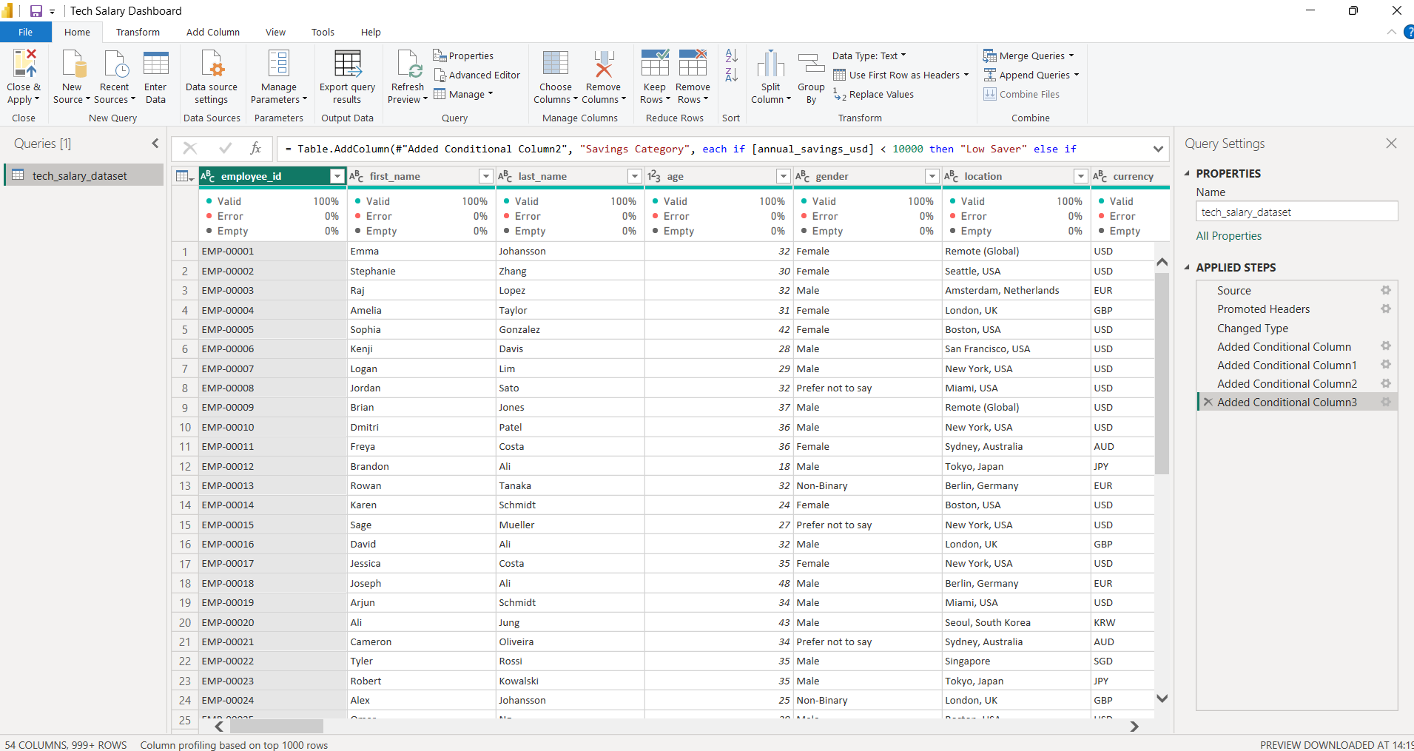

DATA MODELING
================================================================

Star Schema
================================================================
Purpose:
FACT TABLE
Employee Fact DIMENSION TABLES
Dim Location Dim_Tech_Field Dim_Job_Title Dim_Education
Dim_Work_Arrangement

RELATIONSHIPS
One-to-Many Relationships

FILTER DIRECTION
Single Direction

MODEL BENEFITS
Improved Performance Easy DAX Development Better Scalability SCREENSHOT
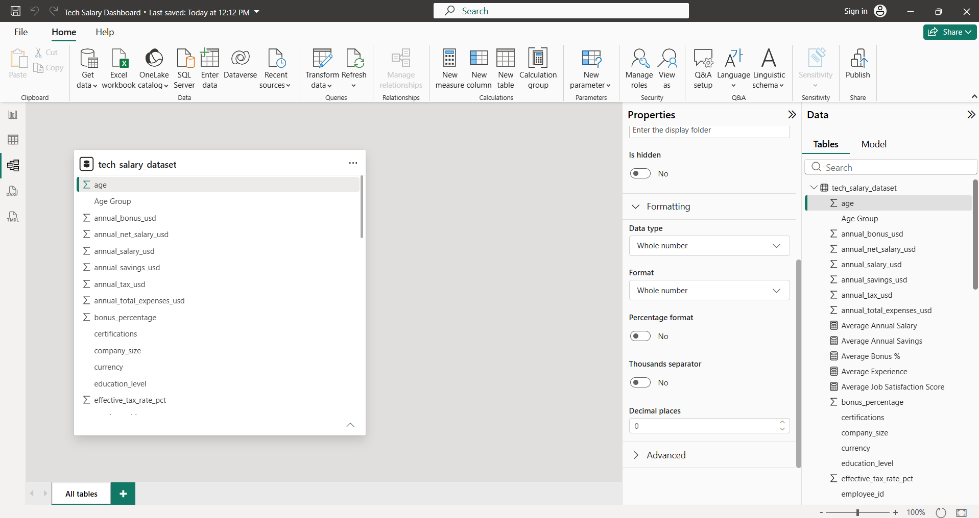

DAX MEASURES USED
================================================================ TOTAL EMPLOYEES
COUNTROWS(Employee_Fact)
PURPOSE : Calculate total workforce count.

AVERAGE SALARY
AVERAGE(Employee_Fact[annual_salary_usd]) PURPOSE : Calculate average annual salary.\

SAVINGS RATE %
DIVIDE( SUM(Employee_Fact[annual_savings_usd]), SUM(Employee_Fact[annual_salary_usd]) )
PURPOSE : Calculate percentage of salary saved.

VISUALIZATIONS USED
================================================================
KPI CARDS: Display key business metrics.
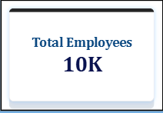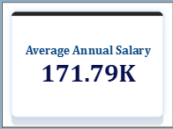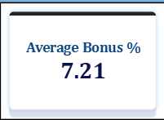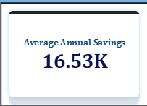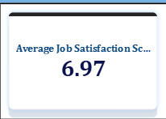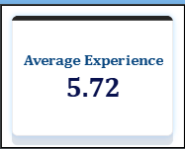

BAR CHART: Compare salary and savings.

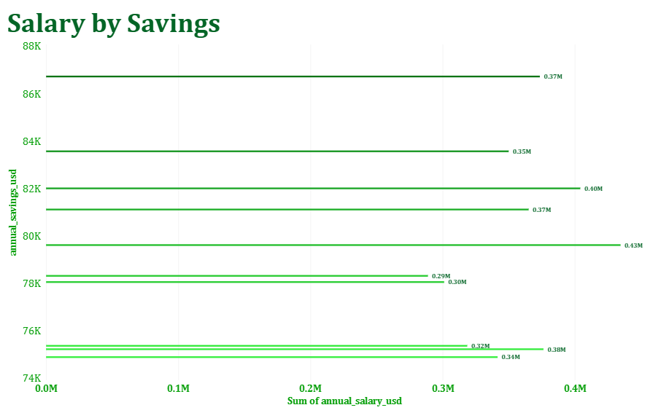
LINE CHART: Show trends over time.
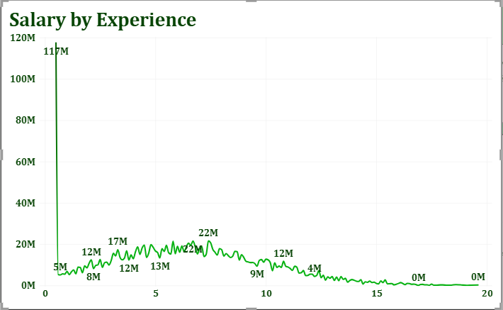

DASHBOARD SCREENSHOTS
================================================================ EXECUTIVE OVERVIEW
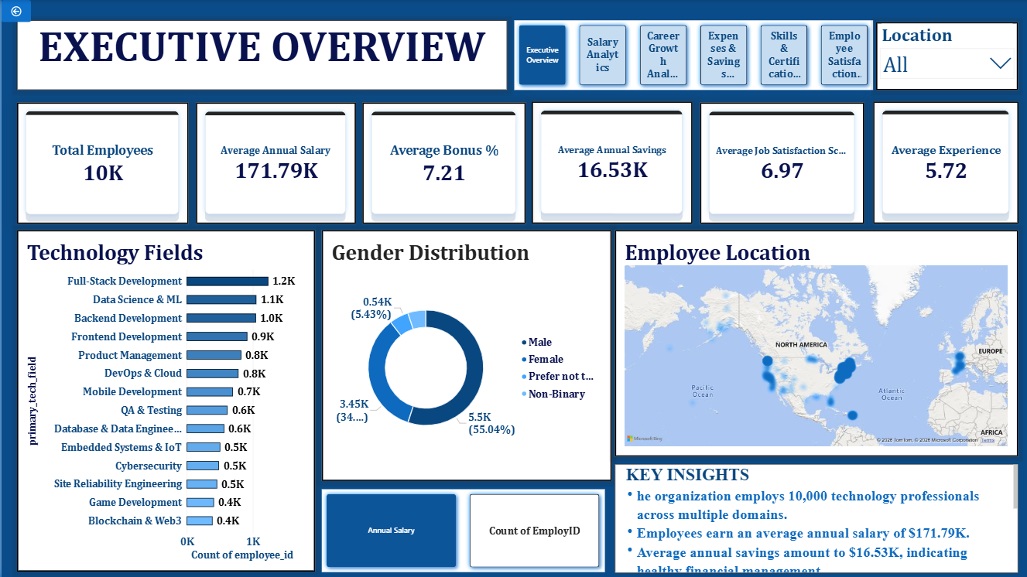
Explanation
This dashboard provides a comprehensive overview of the technology workforce,
highlighting key performance indicators such as total employees, average salary,
average savings, bonus percentage, job satisfaction score, and experience level. It
also presents workforce distribution across technology fields, gender demographics,
and employee locations to provide a quick understanding of the organization's
workforce composition.

SALARY ANALYTICS
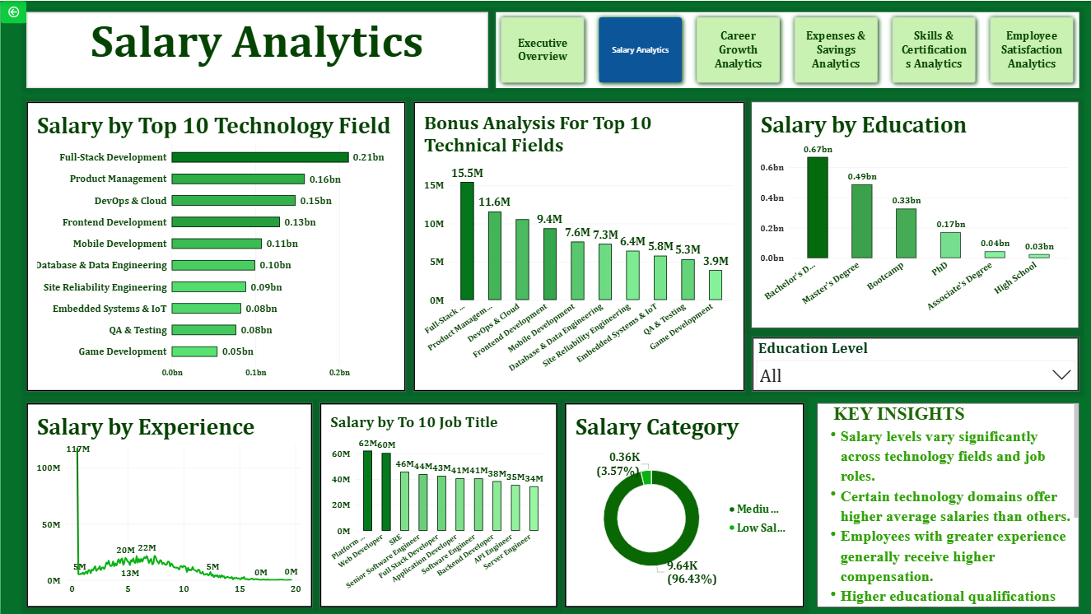
Explanation
This dashboard analyzes employee compensation patterns across different
technology fields, job roles, education levels, and experience levels. It helps identify
the highest-paying roles, technology domains with competitive salaries, and the relationship between experience and earnings. The insights support compensation benchmarking and workforce planning decisions..

CAREER GROWTH ANALYTICS
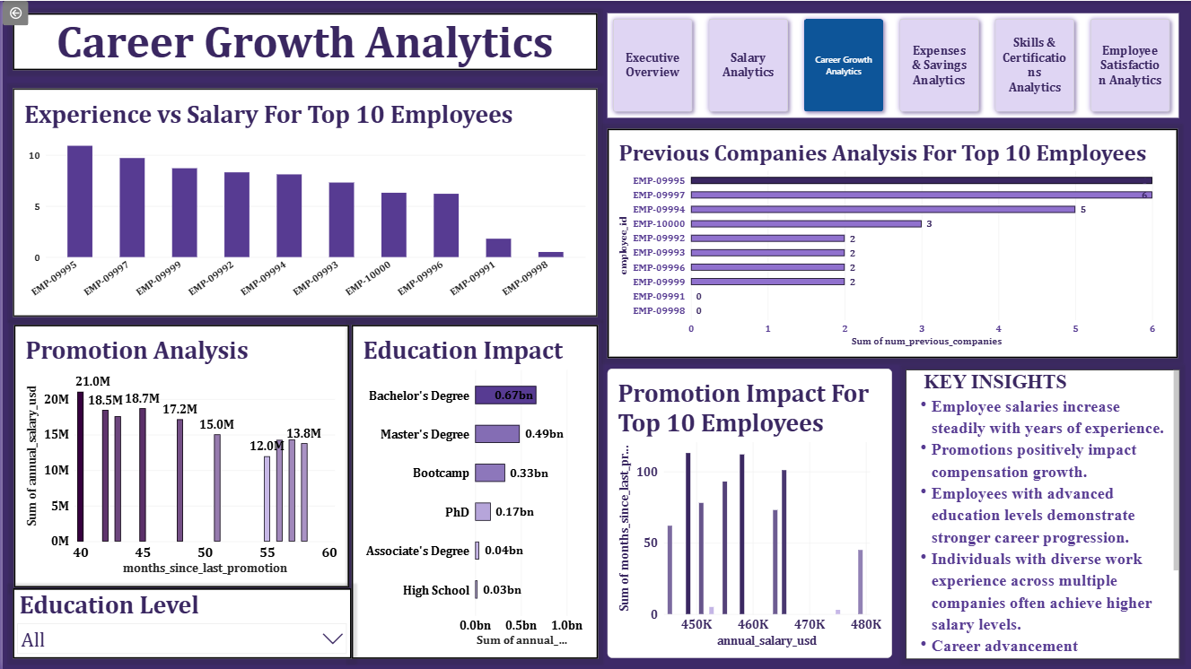
Explanation
This dashboard focuses on employee career progression by examining the impact of experience, education, promotions, and previous work history on salary growth. It helps identify factors that contribute to career advancement and provides insights into workforce development opportunities within different technology domains.

EXPENSES & SAVINGS ANALYTICS

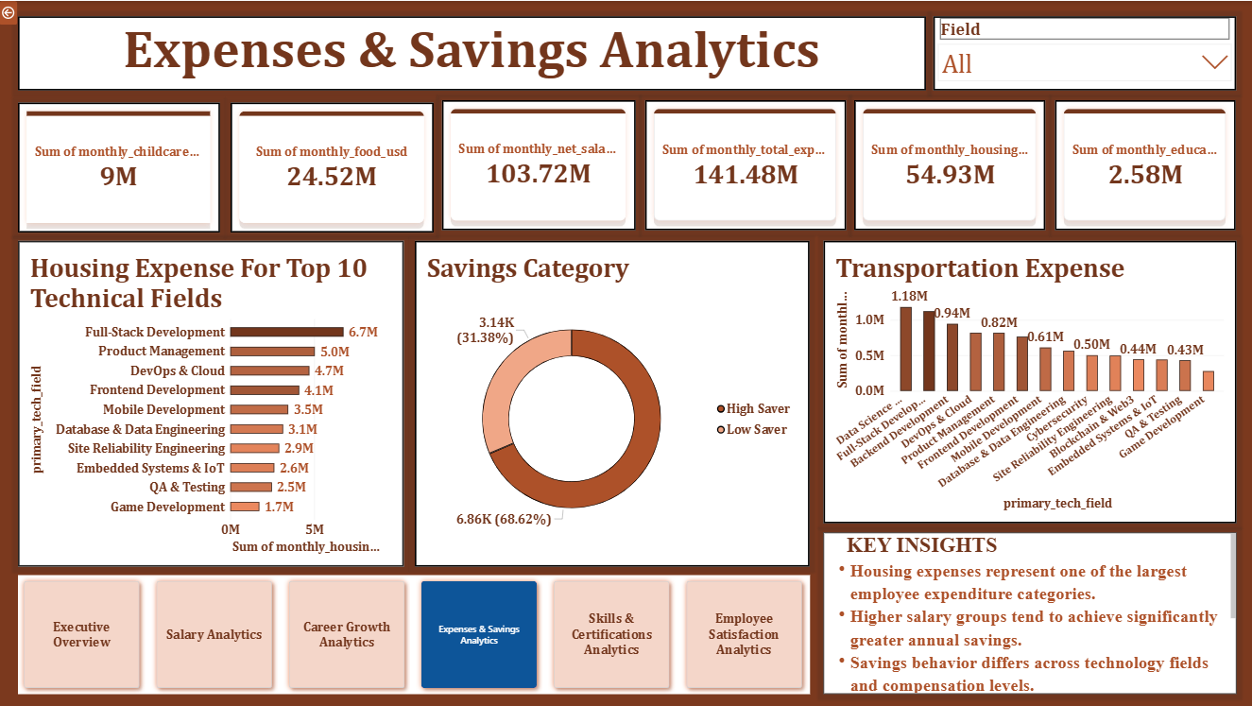
Explanation
This dashboard evaluates employees' financial health by analyzing spending patterns across housing, food, transportation, and healthcare expenses. It compares annual expenses with savings levels and highlights how salary groups influence saving behavior. The analysis helps understand employees' financial well-being and spending trends.

SKILLS & CERTIFICATIONS ANALYTICS

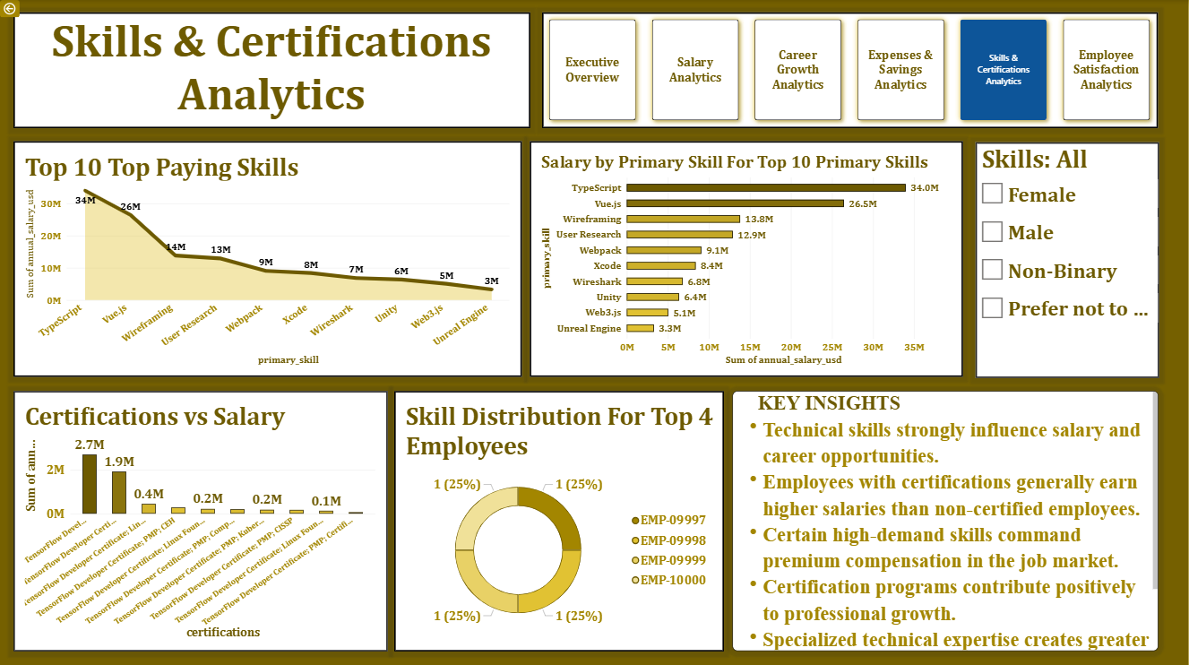

Explanation

This dashboard examines the relationship between technical skills, certifications, and employee

compensation. It identifies the most valuable skills, highest-paying technologies, and the impact of certifications on salary growth. The insights help organizations and professionals understand skill demand and career development opportunities.

EMPLOYEE SATISFACTION ANALYTICS

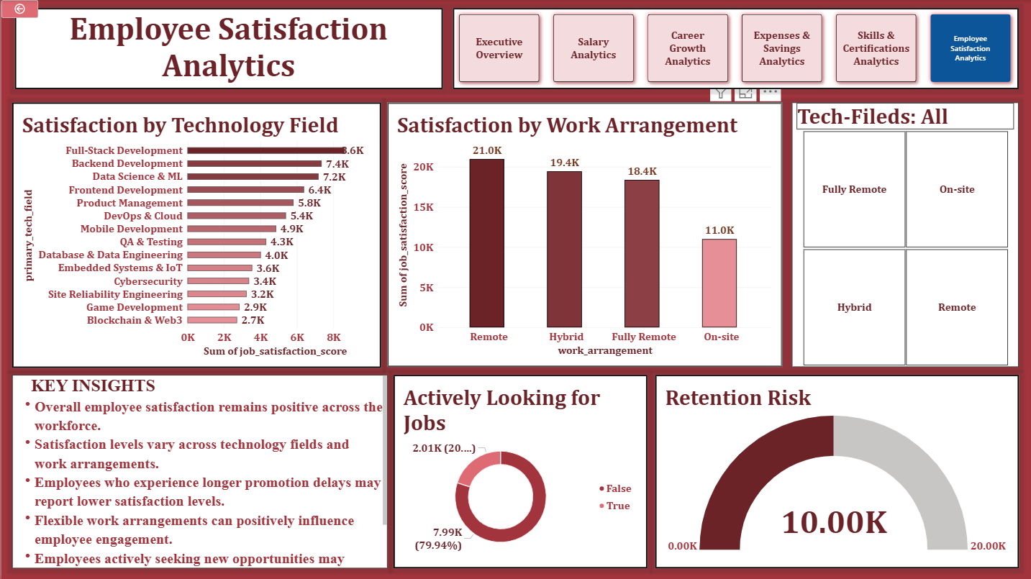
Explanation

This dashboard measures employee satisfaction across technology fields, work arrangements, and promotion histories. It also analyzes employees actively seeking new opportunities and identifies factors that influence workplace satisfaction. The findings help assess employee engagement, retention risks, and overall workforce morale.

KEY INSIGHTS
================================================================ INSIGHT-1
Employees with specialized technical skills earned higher salaries.

INSIGHT-2
Certified employees demonstrated better compensation growth.

INSIGHT-3
Remote employees show higher job satisfaction scores.

BUSINESS RECOMMENDATIONS
================================================================ RECOMMENDATION-1
Invest in certification programs.

RECOMMENDATION-2
Promote employee upskilling.

RECOMMENDATION-3
Strengthen retention strategies.

RECOMMENDATION-4
Provide financial wellness programs.

FEATURES IMPLEMENTED
================================================================
✔ Drill Down
✔ Drill Through
✔ Tooltips
✔ Dynamic Titles
✔ Slicers
✔ Conditional Formatting
✔ Navigation Buttons

✔ Bookmarks
✔ Custom Theme

CHALLENGES FACED
================================================================
Data Cleaning Challenges Relationship Management DAX Optimization Dashboard Layout Design Performance Tuning

LEARNINGS
================================================================
Power Query Data Modeling
DAX Development Dashboard Design Storytelling Business Analysis

PROJECT STORYTELLING
================================================================

BUSINESS SCENARIO
Technology organizations generate large amounts of workforce data related to salaries, experience, skills, expenses, savings, and employee satisfaction.
However, decision-makers often struggle to convert this information into meaningful business insights that support workforce planning and employee retention.

BUSINESS PROBLEM
- Which technology fields provide the highest compensation?
- How does experience affect salary growth and financial stability?
- Do certifications and specialized skills increase earnings?
- Which employees demonstrate better savings behavior?
- What factors influence employee satisfaction and retention?

ANALYSIS APPROACH
- Analyzed workforce compensation across technology domains.
- Compared salary growth against experience and education levels.
- Evaluated employee expenses and savings patterns.
- Measured the impact of skills and certifications on earnings.
- Analyzed job satisfaction and retention indicators.

KEY FINDINGS
================================================================
Employees with specialized technical skills earned higher salaries.
Certified employees demonstrated better compensation growth.
Experienced employees maintained higher savings rates.
Remote and flexible work arrangements showed higher satisfaction scores.
================================================================

BUSINESS IMPACT
================================================================
Supports compensation planning. Improves workforce development. Enhances employee retention strategies. Provides data-driven HR insights.
Enables better workforce decision-making.

PROJECT DEPLOYMENT
================================================================ DEPLOYMENT OBJECTIVE
Deploy the Power BI solution to enable stakeholders to access interactive dashboards and business insights in real time.

DEPLOYMENT PLATFORM

Power BI Service

DEPLOYMENT PROCESS
Power BI Service

STEP-1
Validate Data Model and DAX Measures in Power BI Desktop.

STEP-2
Optimize Dashboard Layout, Performance, and User Experience.

STEP-3
Publish PBIX File to Power BI Service.

STEP-4
Configure Dataset Refresh Settings.

STEP-5
Create Dashboard from Published Reports.

STEP-6
Apply Security and Access Permissions.

STEP-7
Share Dashboard with Business Stakeholders.

BUSINESS BENEFITS
Centralized Reporting Platform. Interactive Workforce Analytics. Real-Time Performance Monitoring. Improved Strategic Planning
Faster Data-Driven Decisions.

CONCLUSION
================================================================
The Tech Workforce Salary & Financial Analytics Dashboard successfully analyzed workforce compensation, financial health, skills, career growth, and employee satisfaction.
The project generated valuable insights that can help organizations improve compensation planning, employee retention, workforce development, and business decision-making.

The dashboard reveals a highly skilled and globally distributed technology workforce with strong compensation levels, positive financial health, and satisfactory employee engagement. Career growth, technical skills, certifications, and professional experience significantly influence employee success, while continued focus on employee satisfaction, career development, and workforce diversity can further strengthen organizational performance.

